Husky Project Report

*Data*

There are 2 fabricators (A and B) that are available 24/7.

Fabricator A requires 35 man-hours, 5 machine hours to make 1 door panel machine and 25 man-hours, 3 machine hours to make 1 syringe machine.

Fabricator B requires 25 man-hours, 8 machine hours to make 1 door panel machine and 15 man-hours, 4 machine hours to make 1 syringe machine.

The company can sell a maximum of 200 door panel machines at $200,000 each. They can sell unlimited syringe machines at $150,000 each. They have 200 tons of steel available as raw material. Door panel machines require 1 ton of steel each. Syringe machines require 0.75 tons of steel each.

*Procedure/Strategy*

1. Calculate the maximum number of door panel and syringe machines that can be produced with the available steel.

2. Calculate the total revenue for maximum door panel machines (200) and remaining syringe machines.

3. Compare the revenue from different combinations of door panel and syringe machines to determine the optimal mix that maximizes total revenue over the 8-week period.

4. Calculate the man-hours and machine hours required on each fabricator to produce the optimal mix.

5. Check that the total man-hours are within the constraints of available workers.

*Problem Formulation*

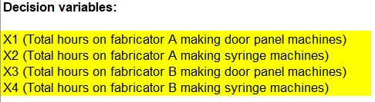



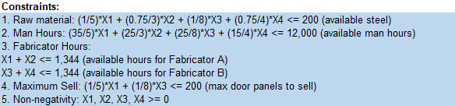

*Findings*

Based on the solution from the solver, here are the findings:

In order to get the maximized revenue of $40,000,000 , below mentioned are the optimized total hours that Fabricator A and B should contribute in making door panel machines and syringe machines:

* 2.05 hours is the optimized number of total hours on Fabricator A making door panel machines.
* 530.06 hours is the optimized number of total hours on Fabricator A syringe making machines.
* 163.03 hours is the optimized number of total hours on Fabricator B making door panel machines.
* 249.05 hours is the optimized number of total hours on Fabricator B making syringe machines.

Above mentioned, optimized number of hours suffice the requirements of all the constraints:

* Raw materials are less than or equal to 200 [available steel].
* The man hours to operate Fabricator A and B is 5874.91 hours which is under 12000 hours [available man hours].
* The hours for Fabricator A is 532.11 hours which is under 1344 [available hours for fabricator A].
* The hours for Fabricator B is 412.08 hours which is under 1344 [available hours for fabricator B].
* The maximum sell is around 20-21 which is under 200 [max door panels to sell].

*Conclusion*

In conclusion, the revenue will only be maximized under the given constraints if the Fabricator A and B making door panel machines and syringe machines operate at an optimized hour, as mentioned above.